Dodge-Perkins Diesel Engine

In 1962 Dodge introduced the Dodge-Perkins Diesel engine as an option to there truck line.

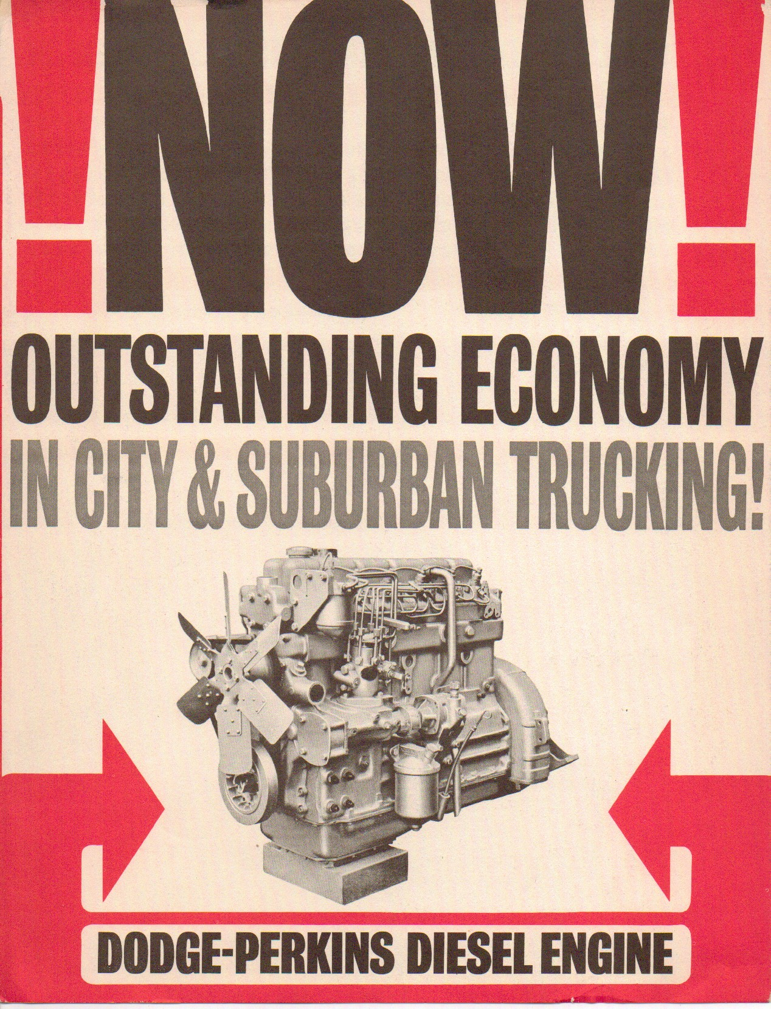

The Dodge-Perkins Diesel engine specifications:

Cylinders – 6
Bore - 3 7/8”
Stroke - 5”
Displacement – 354 cu.in.
Comp. Ratio - 16 to 1
120 HP @ 2800 rpm.
260 lbs/ft Torque @ 1200 rpm.

This option was marketed as an option to medium-tonnage truck line only which included:

PD500 & PD600
PC500 & PC600

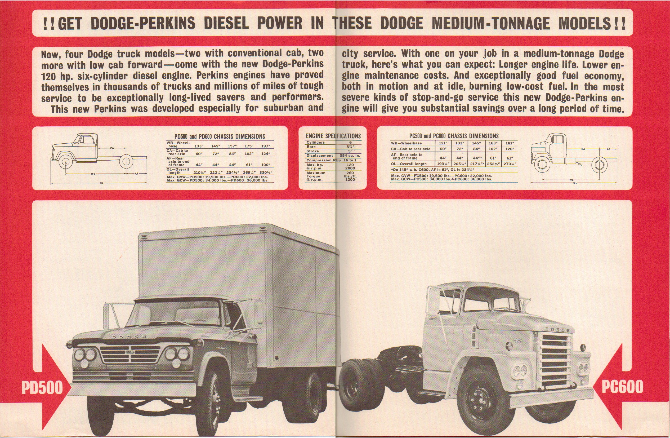

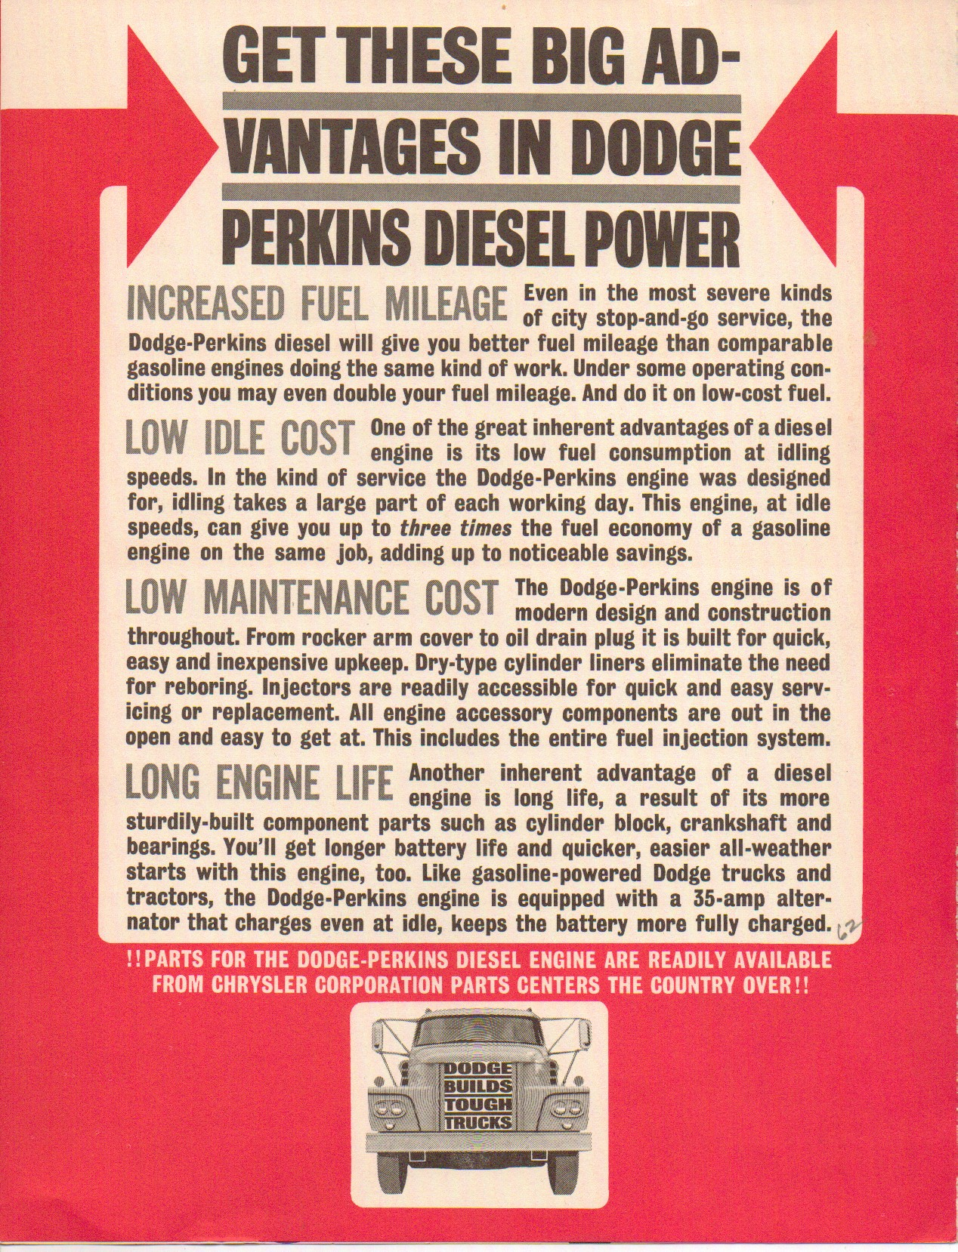

Although, the Perkins was only marketed for Medium-Tonnage line it was available for Light-Tonnage and Heavy-Tonnage trucks.
The Heavy-Tonnage line included other Perkins Diesel engine as well.
For this article I’m going to stick to the 6-cyl. 354 engine.
If you asked your dealer, I’d really like to purchase a W300 with a diesel engine? His response would have been “No problem, we can order it for you for an additional cost of $908.90 and it will only add 5 extra days for delivery”. So, even though it wasn’t marketed, it was available in other truck lines.

The Perkins Diesel option was available for the following:
Item No. 28-01A - W300, D400
Item No. 28-01B - S500, W500
Item No. 28-01C - S500, S600 – 240” WB
Item No. 28-01D - S600 – 258” WB

The Perkins Diesel option included, a 13” clutch & (2) 70 amp. hour batteries.

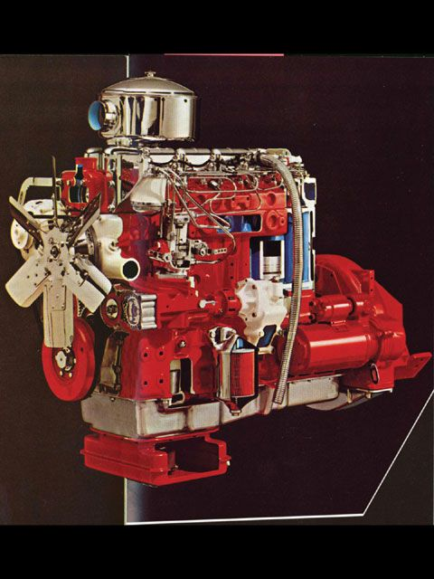

As of now, we have one W300 in existence owned by Aaron Arnold from Kendall, Texas that has a 1964 W300 Crew Cab with the 28-01A option.

The truck was purchased new by a ranch owner in Montana. Aaron purchased the truck in 1997, with the knowledge that it would need major work to the drive train because of the flood damage. He got the truck home, drained all the fluids, put a battery in it and started it right up. The truck only needed minor service to get it on the road again. Water had come into the cab, but no damage really occurred. He has added a 6.5 utiline bed, and converted to SRW. He used the truck frequently for several years, and made a few 3-4 hour trips to PW events at Fort Hood. It averaged 17 mpg with its factory Perkins 6.354. It has turned out to be quite a rare Sweptline, the only known vintage Diesel Power Wagon, and only a hand full of special built W300 Crew Cabs. It is the grand dad to today's popular Diesel Crew Cab 4x4s.

Aaron’s truck also has, stretched chassis (146”), Bostrom Viking T-bar seats, MU-2A Winch, 20" steering wheel, Heavy-Duty instrument cluster, NP 420 4-speed and 4.88 gears. Aarons truck was the 44,002 truck to roll off the assembly line in 1964, it is unknown as to how many of these 28-01A trucks were built. One thing is for sure there is one that survived and thanks to Aaron it’s still around. Thanks Aaron for all your help and preserving a rare piece of Dodge history.

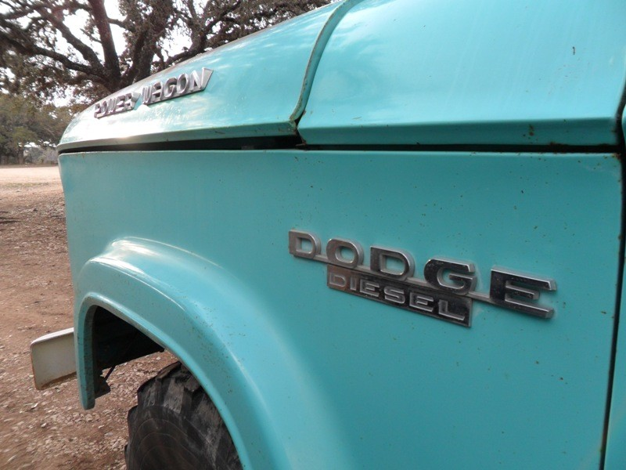

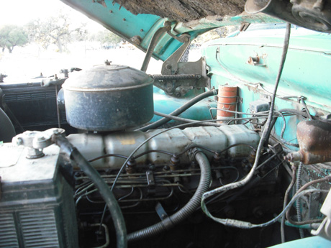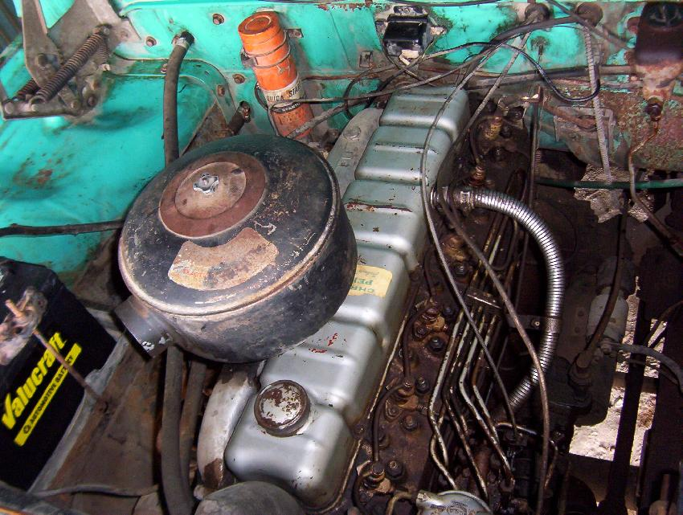

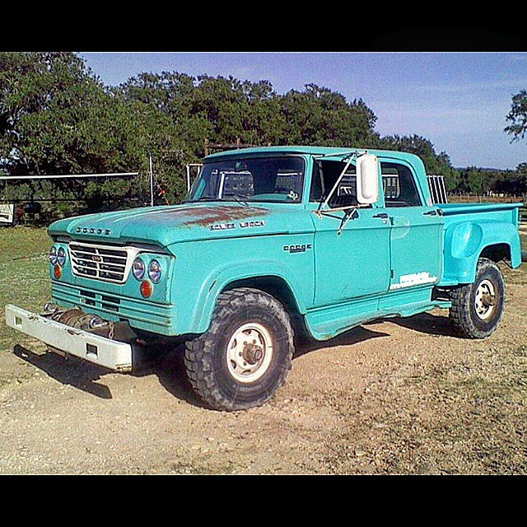

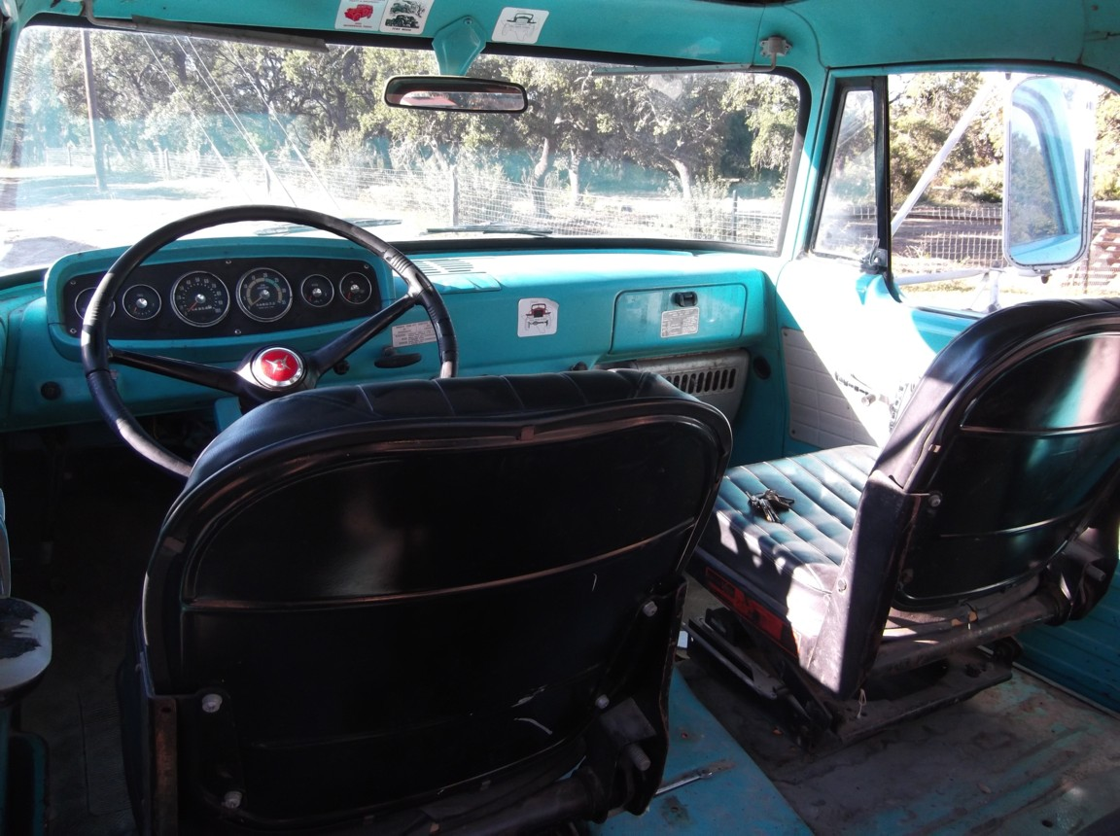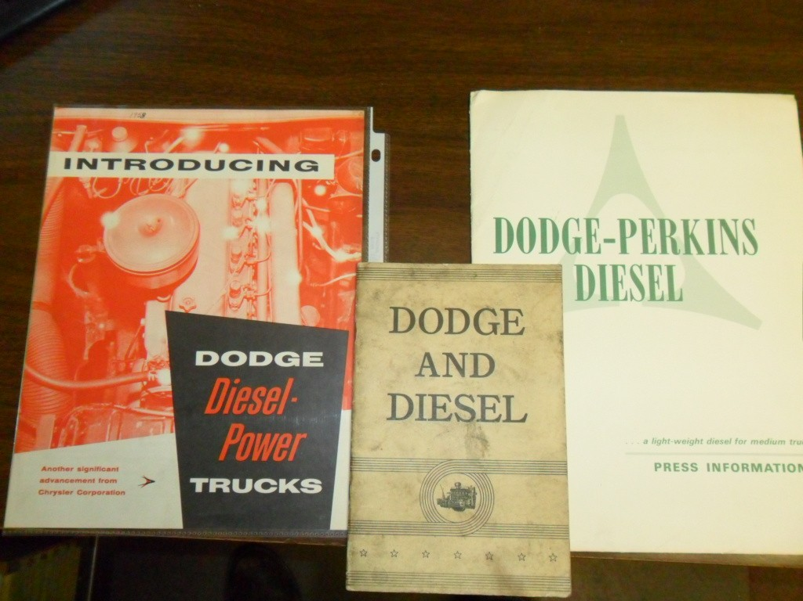

www.dodgesweptline.org.
Copyright © 2016 - Mark D.
All Rights Reserved

